Contents

- Connecting to Biowulf
  - With a Mac computer
  - With a Windows PC
- The command line
- Handy unix commands
- Unix tips and tricks
- File transfer connections to Biowulf
  - Globus.org
  - Mount a drive
  - WinSCP (windows)
  - scp at the command line (Mac)
  - FileZilla (Mac and PC but be very careful downloading this file from the web)
- File formats
  - FASTA, FASTQ
  - SAM, BAM

- Modules (blast, fastxtoolkit, fastqc, bowtie, samtools)
- IGV (Integrated Genome Viewer)
- Additional resources

- Connecting to Biowulf
  - On Mac, open the “Terminal” program and type
“ssh username@biowulf.nih.gov” (without the quotes)

  - On PC, you will need to download and install PuTTY from:
https://www.chiark.greenend.org.uk/~sgtatham/putty/latest.html

Host Name: biowulf.nih.gov
Connection Type: SSH

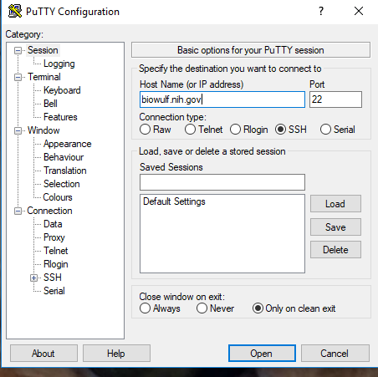
- The Command line [username@biowulf ~] $
  - “username” is your username
  - @biowulf means you are logged into biowulf
  - “~” indicates your home directory
  - When you see the dollar sign “$”, you know you are at the command line
  - If you don’t see the dollar sign, something is going on (running a program)

- Handy unix commands
  - pwd (print working directory)
  - ls (list contents)
  - cd (change directory)
  - cd .. (go to home directory)
  - cd /home/pathtofile
  - less – peek inside a file, press “q” to quit
  - ls -l (list details)
  - ls -a (list hidden . files)
  - rm (remove file)
  - rmdir (remove directory)
  - mkdir (make directory)
  - nano file.txt (nano editor for creating files)
  - move – move or rename files

- Unix tips and tricks
  - Use the “up arrow” to go back to the previous command
  - Use “tab complete” to finish typing a uniquely named file, directory or program

- File transfer connections to Biowulf
  - Globus.org
    - Setup your Globus endpoint (only need to do this one time)
    - Open Globus Connect Personal (need to do this every time)
    - Go to globus.org
    - Choose your personal endpoint
    - Choose a folder on biowulf
    - Click the blue arrow
    - You get an e-mail when it’s done!
    - Need to have helix/biowulf account to get globus

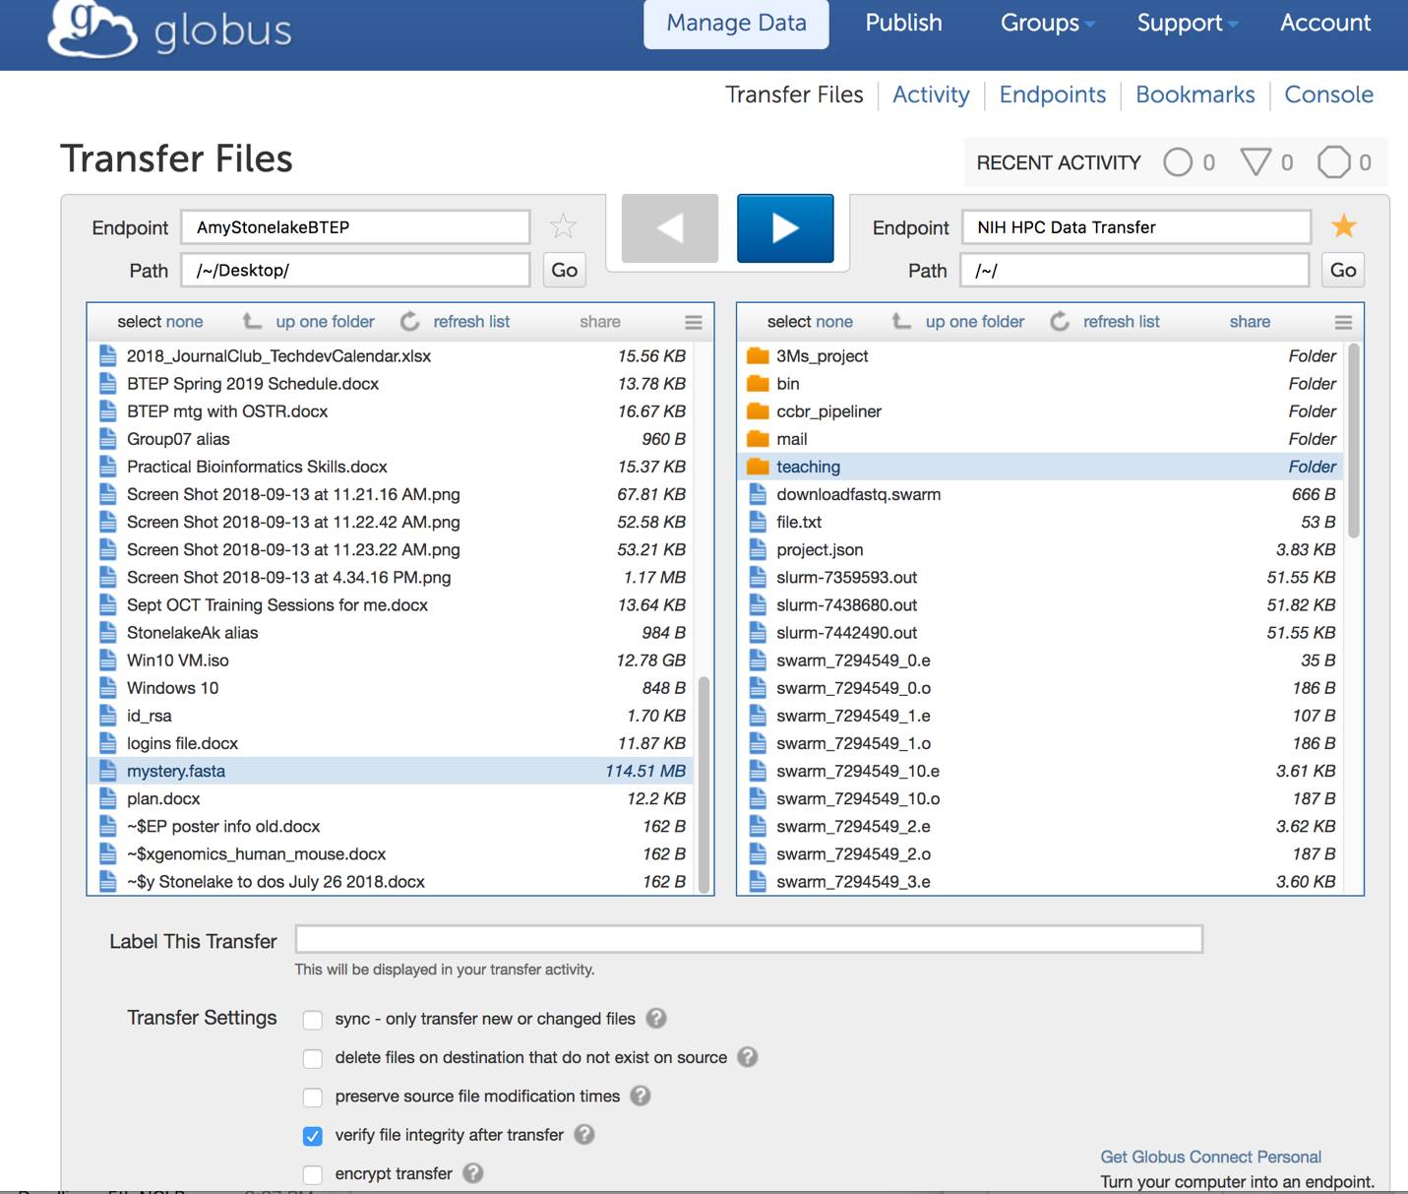

  - Mount a drive
    - Mac – “Go” -> ”Connect to server”
    - PC - ”Computer”, “Tools” then “Map Network Drive” tab
    - Be sure to set host as “smb://biowulf.nih.gov””
    - See instructions on hpc.nih.gov (Biowulf) – “How To – Transfer Files”, “Transferring data to/from the NIH HPC systems

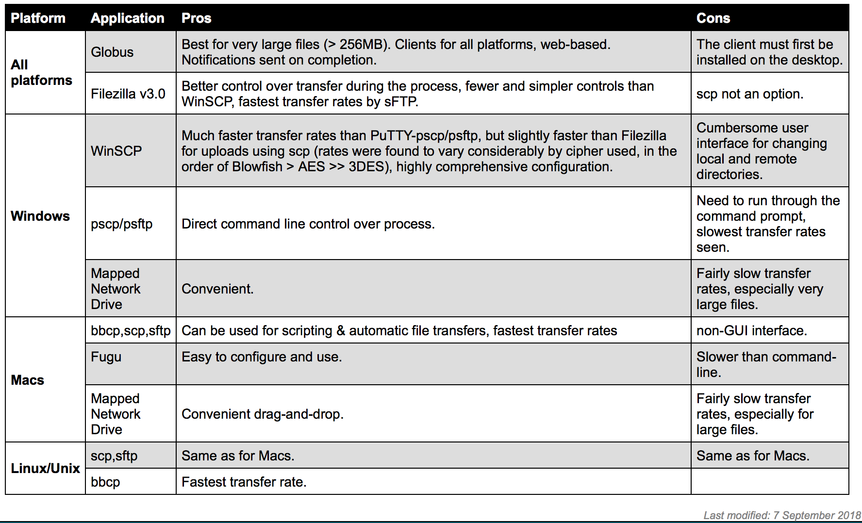

  - Secure ftp (sftp) or secure copy protocol (scp)
    - FileZilla – be sure to get a clean copy!
    - Mac OSX:
http://packages.partek.com/bin/filezilla/fz-osx.app.tar.bz2
    - Windows 32-bit:
http://packages.partek.com/bin/filezilla/fz-win32.exe
    - Windows 64-bit:
http://packages.partek.com/bin/filezilla/fz-win64.exe

FileZilla
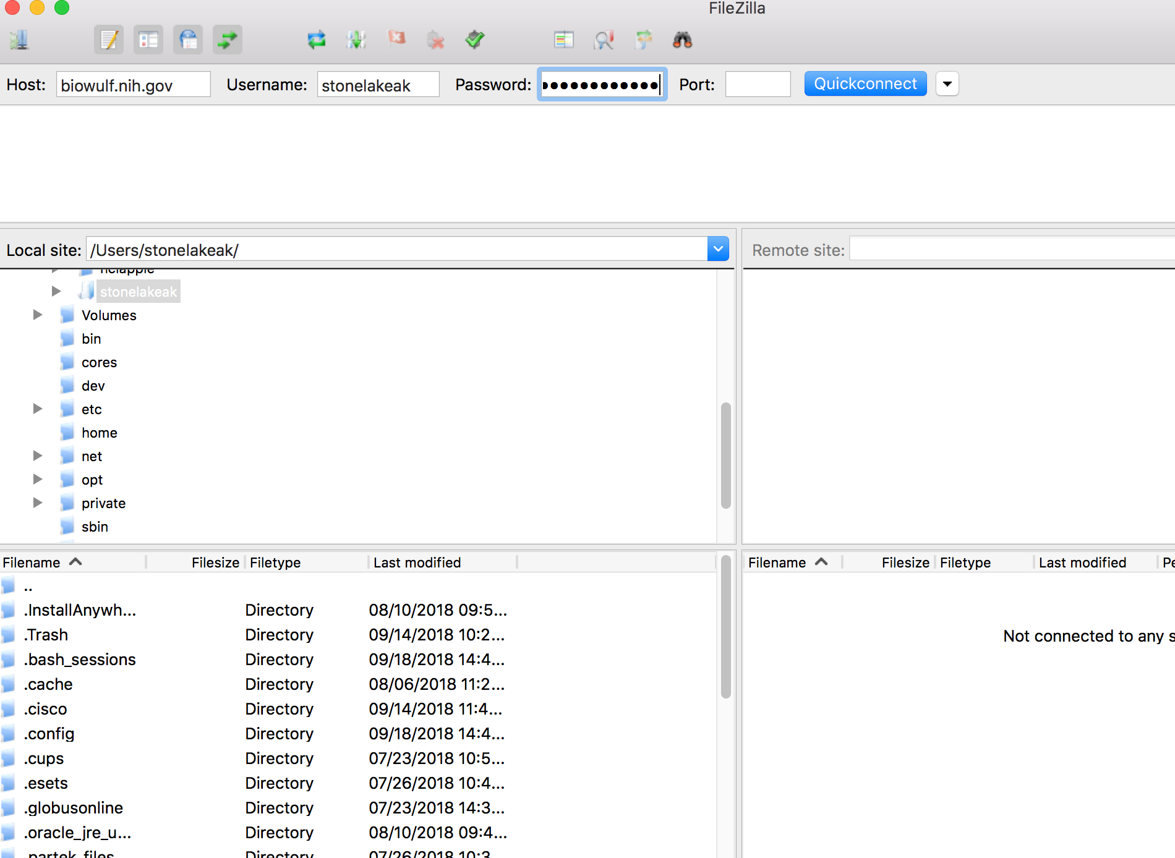

FileZilla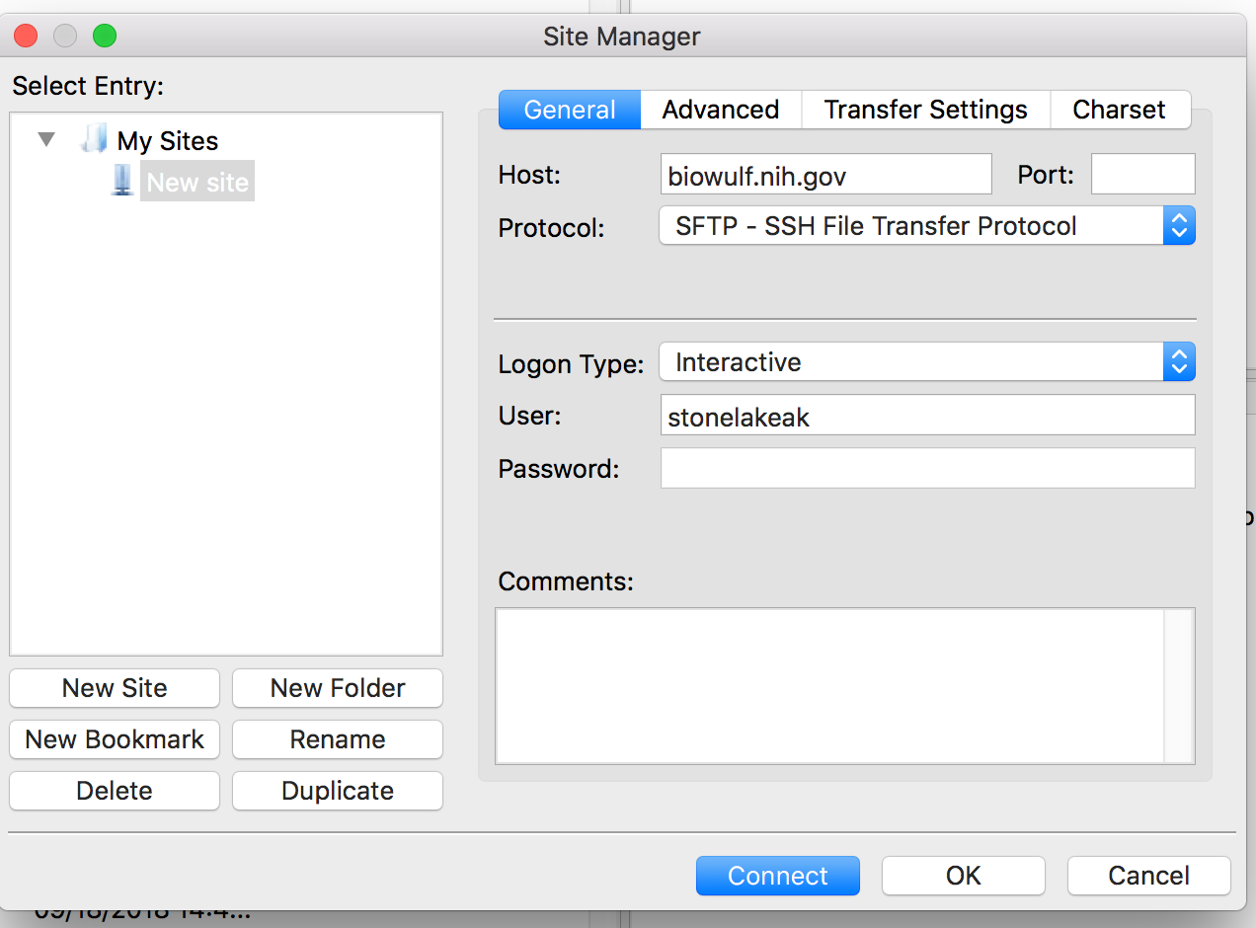

WinSCP
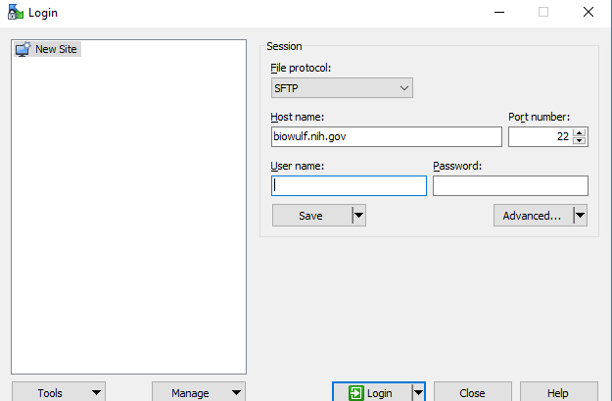

- File Formats
  - FASTA format format has a header line followed by sequence data
>this_is_the_name_of_the_sequence
ACAGATAGACCAGATGACAGACAGATT
  - FASTQ – contains both sequence data and quality scores
  - SAM – stores biological sequence aligned to a reference
  - BAM – binary format of SAM, can be indexed

- Modules (fastqc, fastxtoolkit, blast, samtools, bowtie)
  - Use “module load” command
  - “module avail” to see list of all modules
  - “module spider” to do text matching on module name
  - module load fastqc
    - fastqc read1.fastq
    - fastqc read2.fastq
    - Generates html report you can download
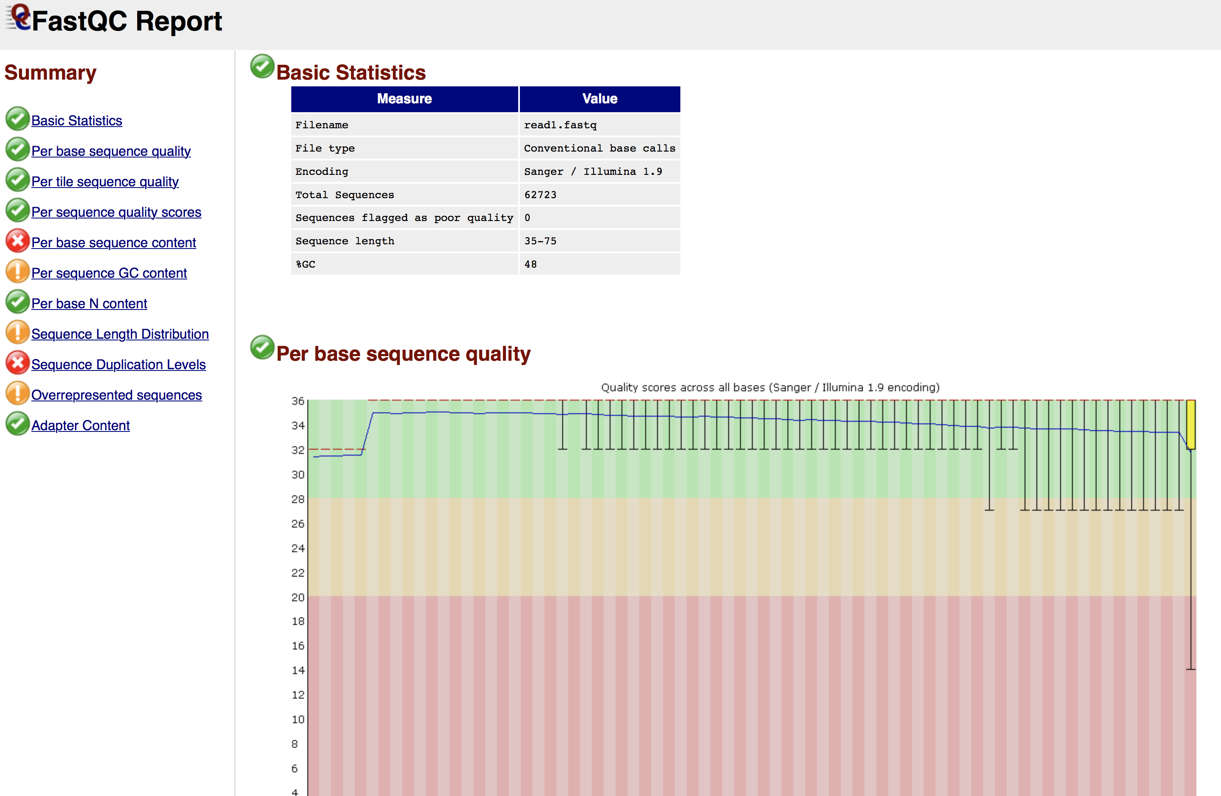

  - module load fastxtoolkit
    - fastq_to_fasta -i input_file – o output_file
  - module load bowtie/2
bowtie2 -x /fdb/bowtie2.DELETE/hg19 -1 read1.fastq -2 read2.fastq -S aligned.sam
  - module load samtools
samtools view -b aligned.sam >aligned.bam
samtools sort aligned.bam >aligned_sorted.bam
samtools index aligned_sorted.bam
  - module load blast
    - easyblast for interactive mode
    - create .swarm file for large batches of sequence data

8. IGV (Integrated Genome Viewer) - software.broadinstitute.org

9. Additional resources
- Book ->“Unix and Perl to the Rescue, A Field Guide for the Life Sciences (and Other Data-rich Pursuits)”, Keith R. Bradnam & Ian Korf, 2012
- Web Site -> korflab.ucdavis.edu, Unix and Perl Primer for Biologists, Korf Lab, UC Davis
- hpc.nih.gov (Biowulf)
- Unix cheat sheet (Fosswire.com)

9. Additional resources
- Book ->“Unix and Perl to the Rescue, A Field Guide for the Life Sciences (and Other Data-rich Pursuits)”, Keith R. Bradnam & Ian Korf, 2012
- Web Site -> korflab.ucdavis.edu, Unix and Perl Primer for Biologists, Korf Lab, UC Davis
- hpc.nih.gov (Biowulf)
- Unix cheat sheet (Fosswire.com)

