Contents

- Connecting to Biowulf
  - With a Mac computer
  - With a Windows PC
- The command line
- Handy unix commands
- Unix tips and tricks
- File transfer connections to Biowulf
  - Globus.org
  - Mount a drive
  - WinSCP (windows)
  - scp at the command line (Mac)
  - FileZilla (only download from a trusted source)
- File formats
  - FASTA, FASTQ
  - SAM, BAM

- Modules (fastqc, bowtie2, samtools)
- Additional resources

- Connecting to Biowulf
  - On Mac, open the “Terminal” program and type
“ssh username@biowulf.nih.gov” (without the quotes)
Enter your password at the prompt.
NOTE: the blinking cursor will not move when you enter your password!
Say “yes” to the government warning message you get the first time you log in.

  - On PC, you will need to download and install PuTTY from
www.putty.org

Host Name: biowulf.nih.gov
Connection Type: SSH

PuTTY interface

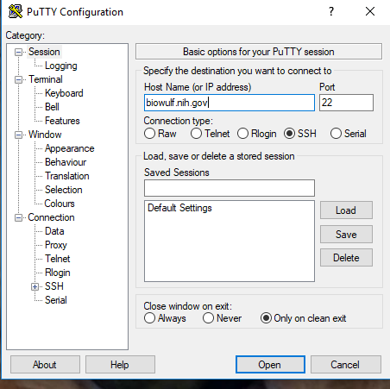
- The Command line
[username@biowulf ~] $
  - “username” is your username
  - @biowulf means you are logged into biowulf
  - “~” indicates your home directory
  - When you see the dollar sign “$”, you know you are at the command line
  - If you don’t see the dollar sign, something is going on (running a program)

- Handy unix commands
  - pwd (print working directory)
  - ls (list contents)
  - cd (change directory)
  - cd .. (go to home directory)
  - cd ../..
  - cd /home/pathtofile
  - less (peek inside a file, press “q” to quit)
  - ls -l (list details)
  - ls -a (list hidden . files)
  - ls -alt
  - rm (remove file)
  - rmdir (remove directory)
  - mkdir (make directory)
  - nano file.txt (nano editor for creating files)
  - mv (move or rename files) mv oldfilename.txt newfilename.txt
  - touch filename.txt (creates an empty file)

- Unix tips and tricks
  - Use the “up arrow” to go back to the previous command
  - Use “tab complete” to finish typing a uniquely named file, directory or program

- File transfer connections to Biowulf
  - Globus.org
    - Setup your Globus endpoint (only need to do this one time)
    - Open Globus Connect Personal (need to do this every time)
    - Go to globus.org
    - Choose your personal endpoint
    - Choose a folder on Biowulf
    - Click the blue arrow
    - You get an e-mail when it’s done!
    - Need to have Helix/Biowulf account to get Globus

The Globus interface

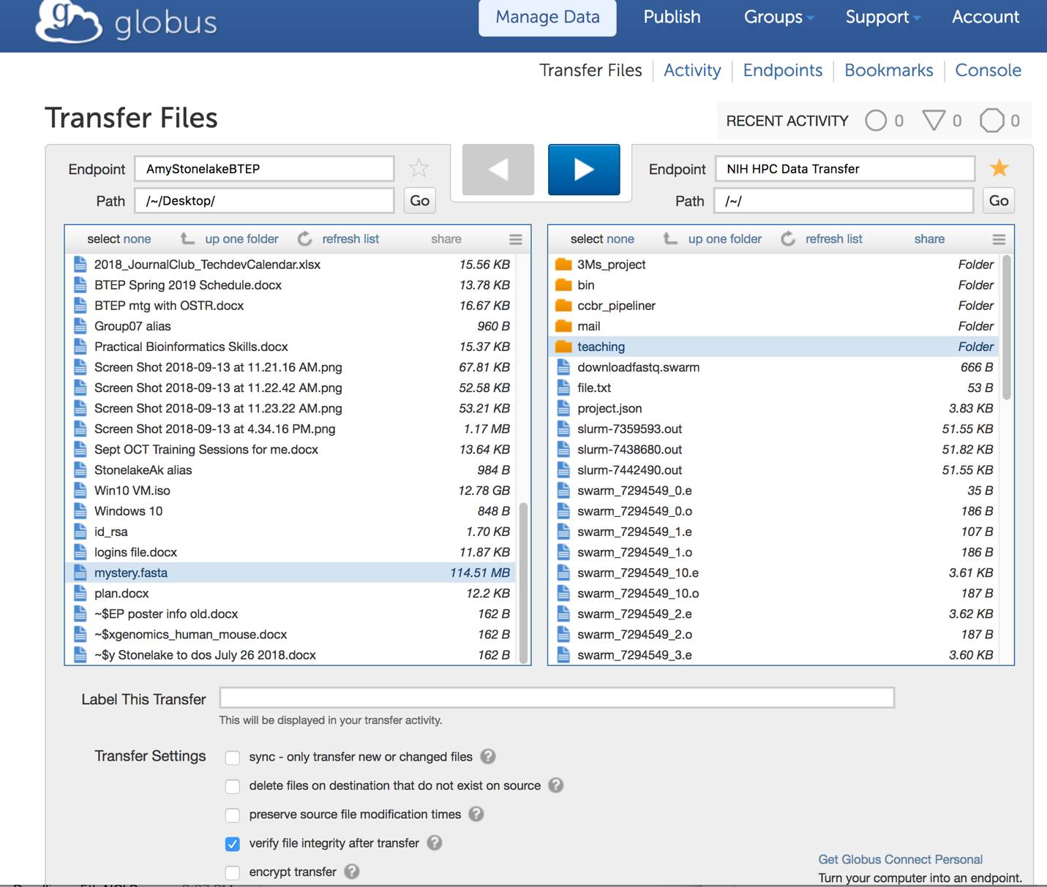

  - Mount a drive
    - Mac – “Go” -> ”Connect to server”
    - PC - ”Computer”, “Tools” then “Map Network Drive” tab
    - Be sure to set host as “smb://biowulf.nih.gov””
    - See instructions on hpc.nih.gov (Biowulf) – “How To – Transfer Files”, “Transferring data to/from the NIH HPC systems

File transfer options on Biowulf (hpc.nih.gov)

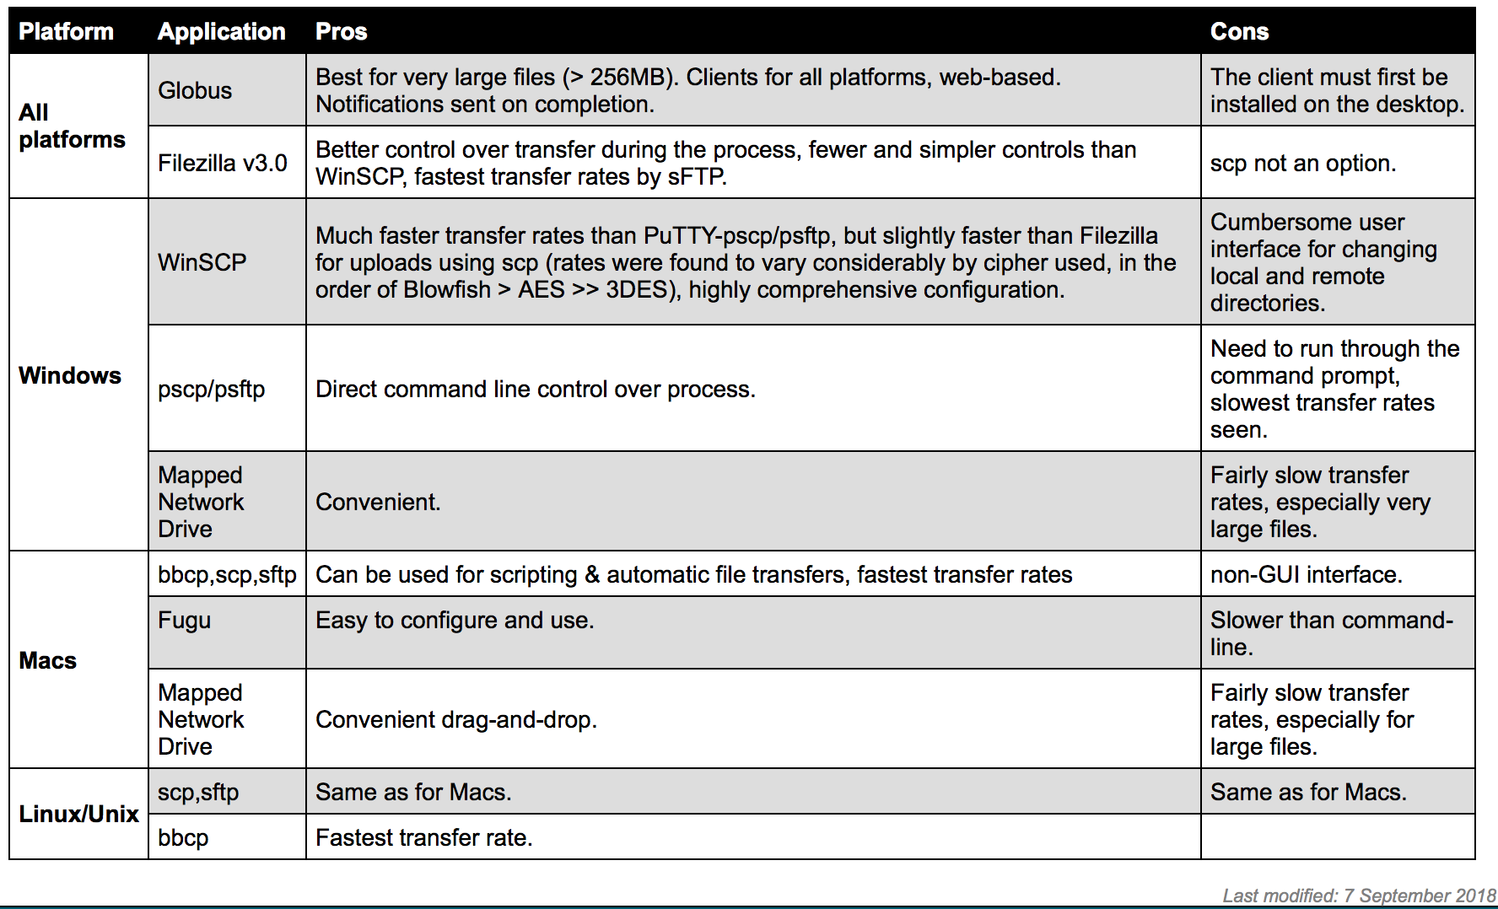

  - Secure ftp (sftp) or secure copy protocol (scp)
    - FileZilla – be sure to get a clean copy!
    - Mac OSX:
http://packages.partek.com/bin/filezilla/fz-osx.app.tar.bz2
    - Windows 32-bit:
http://packages.partek.com/bin/filezilla/fz-win32.exe
    - Windows 64-bit:
http://packages.partek.com/bin/filezilla/fz-win64.exe

Logging into Biowulf with FileZilla
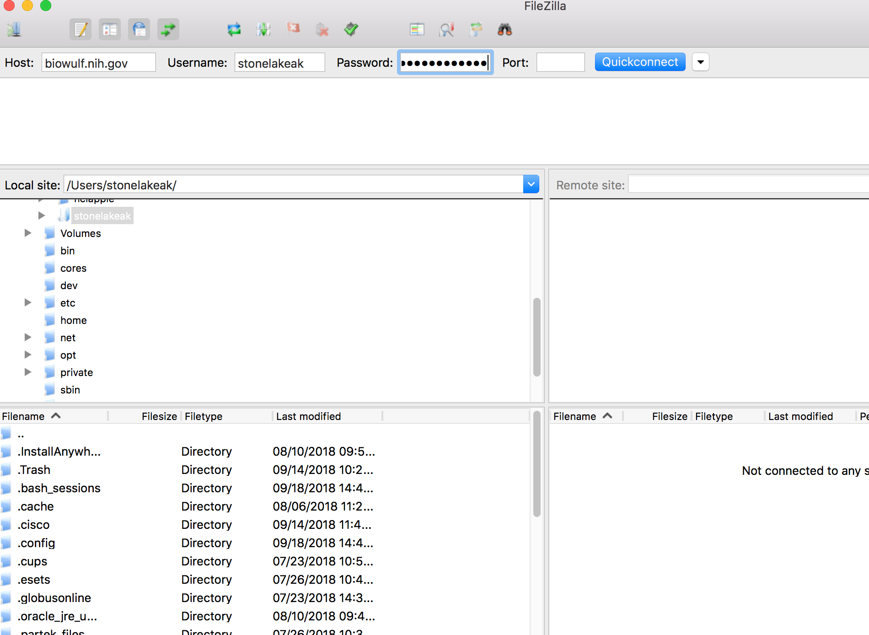

Setting up your connection to Biowulf with FileZilla

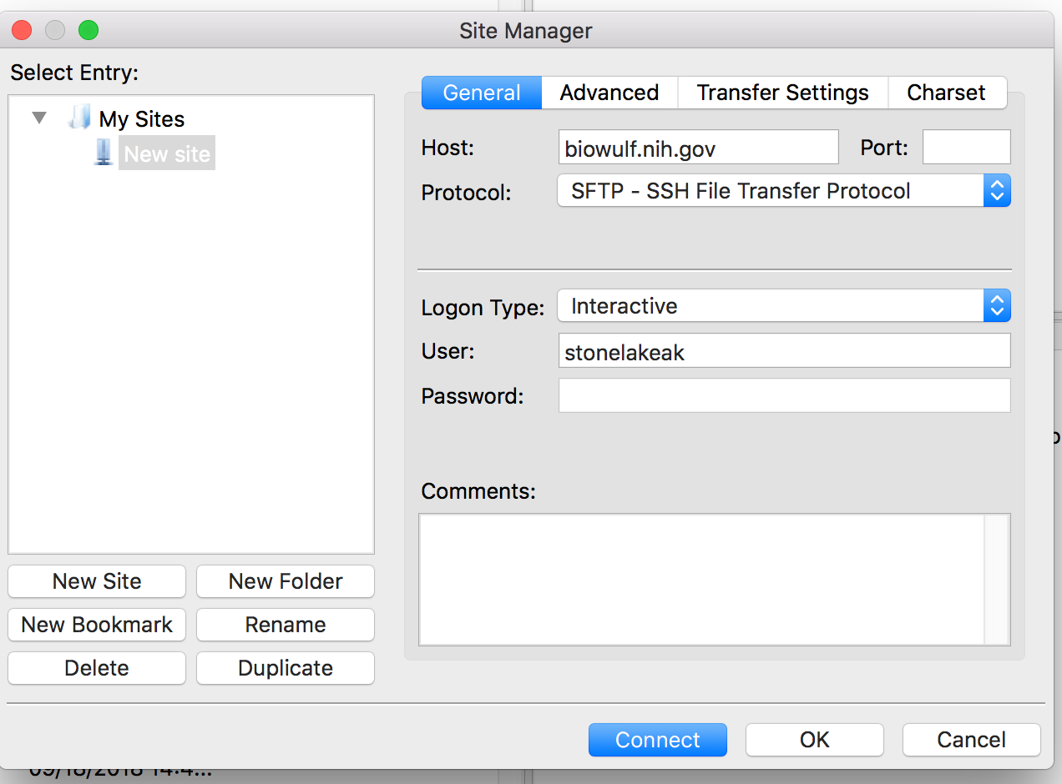

Download WinSCP from winscp.net
This tool is only for PC, not Mac.

WinSCP SFTP login interface
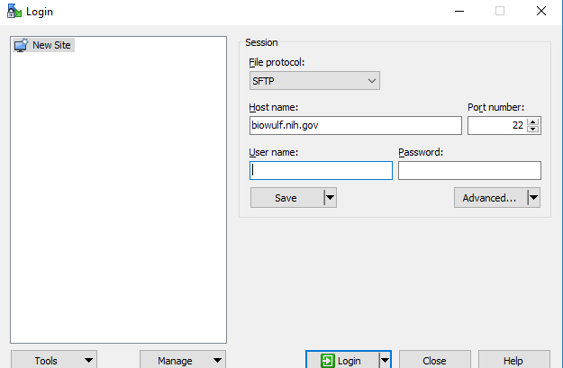

- File Formats
  - FASTA format has a header line followed by sequence data

FASTA formatted sequence

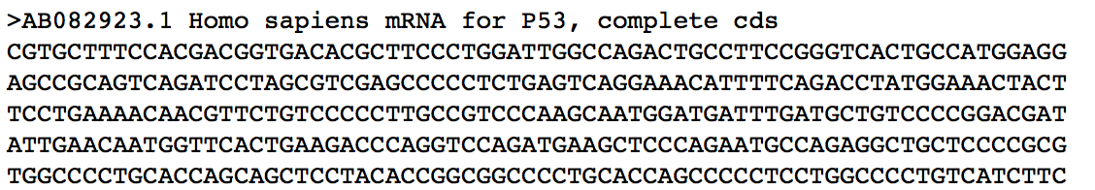

  - FASTQ files contain sequence data that includes a quality (Phred) score for each nucleotide. Quality (Q) scores are integers usually between 2-40.
    - line 1 starts with '@' character followed by a sequence identifier and optional description that may include instrument ID, run number, lane number, tile number, X and Y coordinates of cluster, read number, sample number from sample sheet.
    - line 2 is the raw sequence letters (ACTG)
    - line 3 begins with a '+' character and is optionally followed by the same sequence identifier (and any description) again
    - line 4 has quality (Q) scores for each base (aka Phred score). Q scores are integer values that represent the estimated probability of an error. If the Q score is 0, the probability that it is incorrect is 1.0, and the ASCII symbol is “!”.
The 4 lines of information in a FASTQ file (drive5.com)
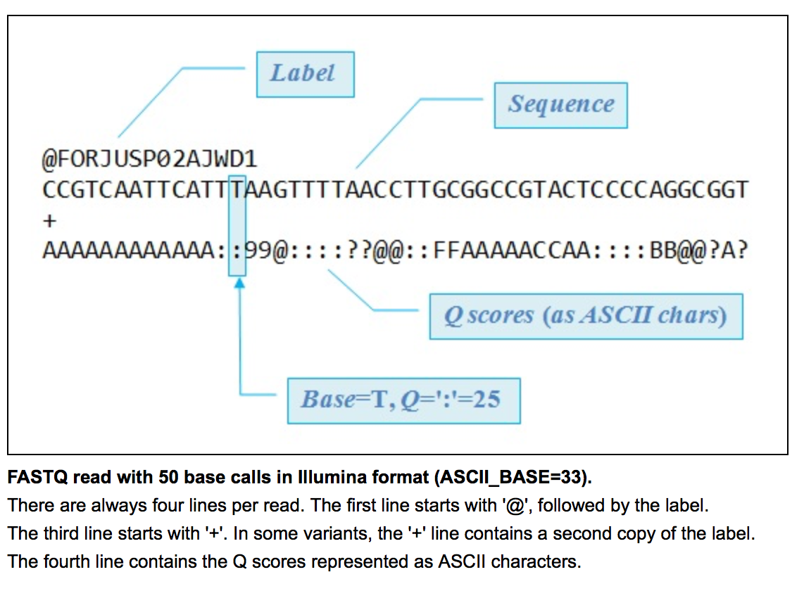

Figure #: Quality scores as represented by ASCII characters (drive5.com)
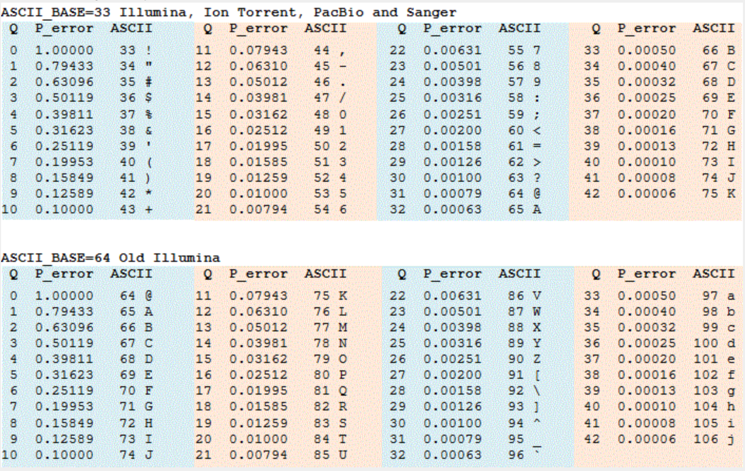

  - SAM – a tab-delimited text file with optional header and alignment sections, use program SAMtools, each alignment has 11 mandatory fields

  - BAM – binary format of SAM, can be sorted and indexed

- Modules (fastqc, multiqc, bowtie2, samtools)
  - Use “module load” command
  - “module avail” to see list of all modules
  - “module spider” to do text matching on module name

- Running jobs on Biowulf – all jobs on Biowulf must be run as interactive, batch or swarm! This is extremely important! Do not run jobs on the Biowulf login node.

- As soon as you login to Biowulf, before you do anything else, start a “sinteractive” interactive session

